Indian Navy Delegation Visits ATIRA to Strengthen Indigenous Composite Technologies
The Ahmedabad Textile Industry’s Research Association (ATIRA) hosted a distinguished delegation from the Indian Navy along with representatives from Sahana Defence Limited at its Centre of Excellence (CoE) for Composites, reinforcing ATIRA’s growing role in advancing indigenous composite solutions for defence applications.
Welcoming the delegation, Director ATIRA, Pragnesh Shah highlighted the institute’s legacy in textile research and its evolution into advanced composites and technical textiles. The visit included a detailed presentation on ATIRA’s integrated capabilities in composite design, manufacturing, and testing.
A key highlight of the visit was the review of FRP-based processes for the Gantry Arch at the Naval EMC Unit, Jamnagar, along with a live demonstration of the pultrusion process. The delegation also visited ATIRA’s comprehensive in-house testing facilities covering mechanical, thermal, electrical, and technical textile evaluation. The team appreciated ATIRA’s proven expertise in delivering high-performance composite solutions for sectors including space, communication, defence, and automotive applications.
Emphasizing the strategic importance of composites in naval systems, Cmde PV Karthik noted:
“Advanced composites are critical to next-generation naval platforms, offering significant advantages in weight reduction, corrosion resistance, and radar transparency. Indigenous capability in this domain is essential for achieving true self-reliance.”
He further encouraged focused collaborations under the Make in India initiative, adding:
“Institutions like ATIRA play a vital role in developing and delivering mission-ready composite solutions for the Navy.”
Potential areas identified for collaboration include integrated mast systems, modular cabins, radomes, shipyard fabrication, and composite-based enclosures.
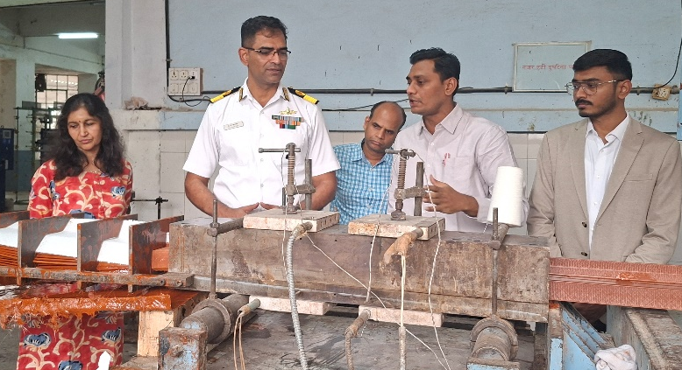
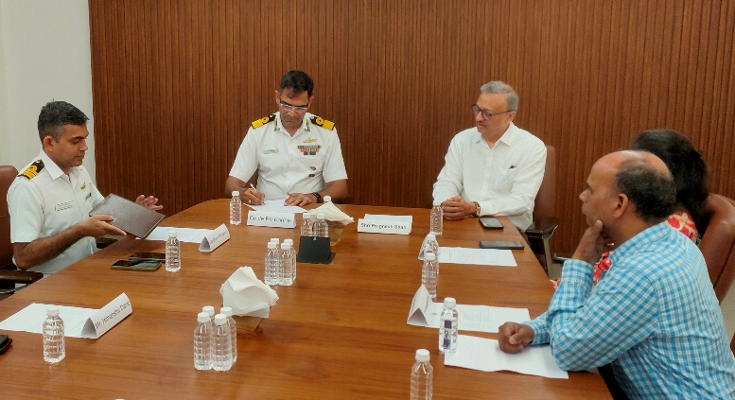
The delegation expressed confidence in ATIRA’s capability to deliver high-quality composite structures within stringent timelines, marking the visit as an important step toward strengthening indigenous defence manufacturing and long-term collaboration.

